Who is your history hero?
Mr. Tarr
chooses
Elvis Presley

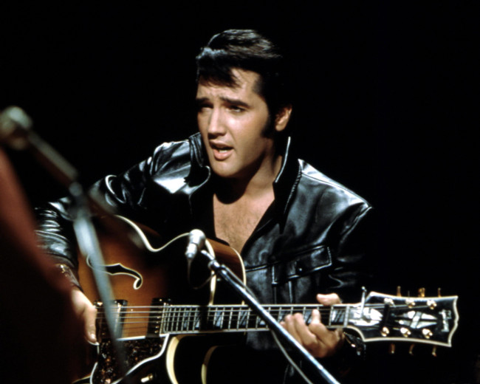

“The image is one thing and the human being is another. It's very hard to live up to an image, put it that way” – Elvis Presley
Elvis Presley was [in a sentence or two, explain who this person was and what they are most famous for]

I think Elvis Presley was heroic because [make sure you use as many of the key words we identified at the start of the study as possible, and put these in bold. Give clear examples from his/her life and career which illustrates your points]

Elvis was historically significant because [Use phrases like “We know he affected a lot of people because…we also know this was in many parts of the world because…We also know that he continues to affect people today because…]

